**Enrolment Walkthrough 2018/19**

**Students will be asked to log in. They will be sent instructions on how to generate their username and password:**

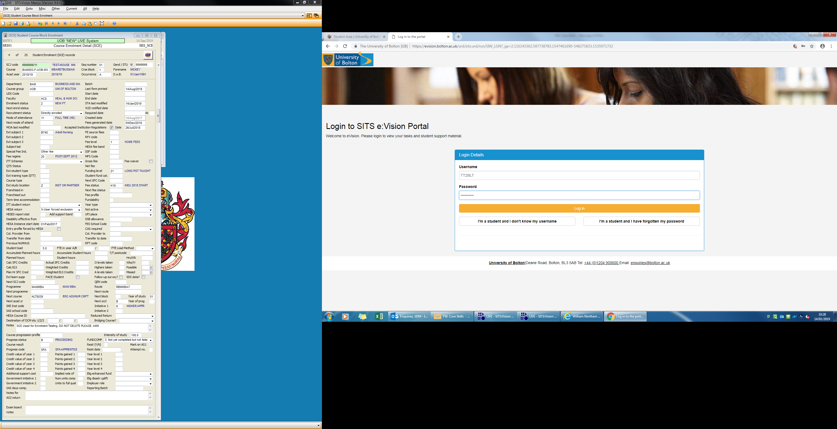

**They will then be asked to enter their date of birth:**

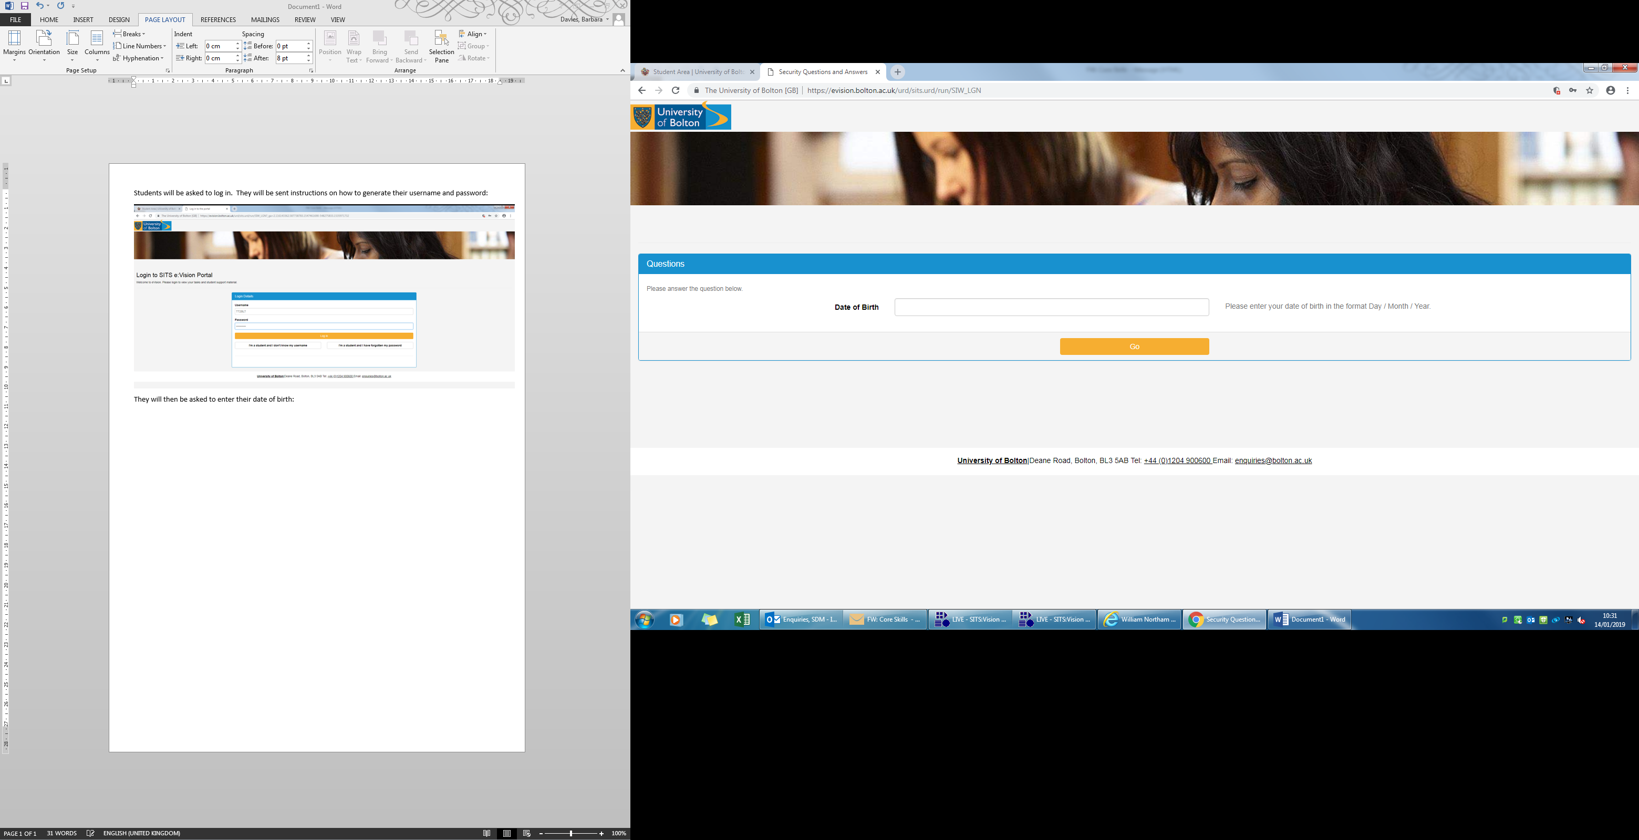

**They must select the course from the dropdown list:**

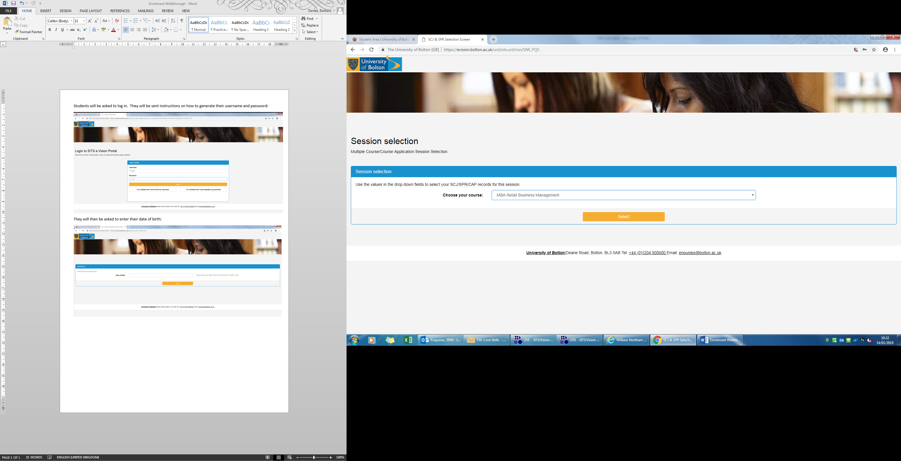

**Click enrol next to the course name:**

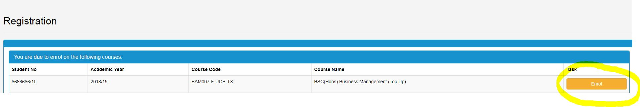

**Work through the screens:**

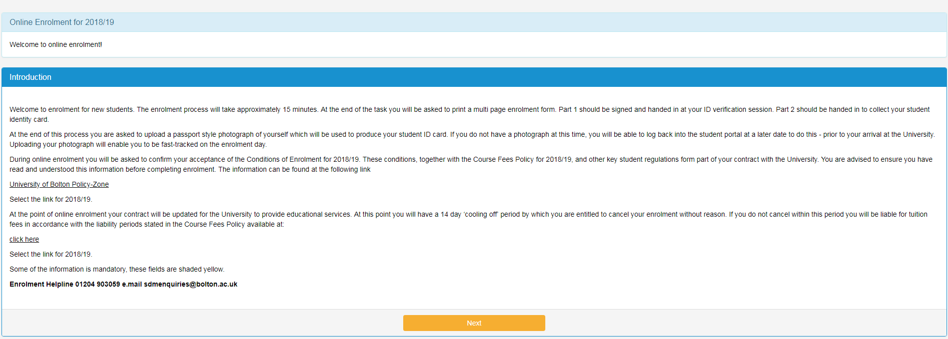

**Confirm your name:**

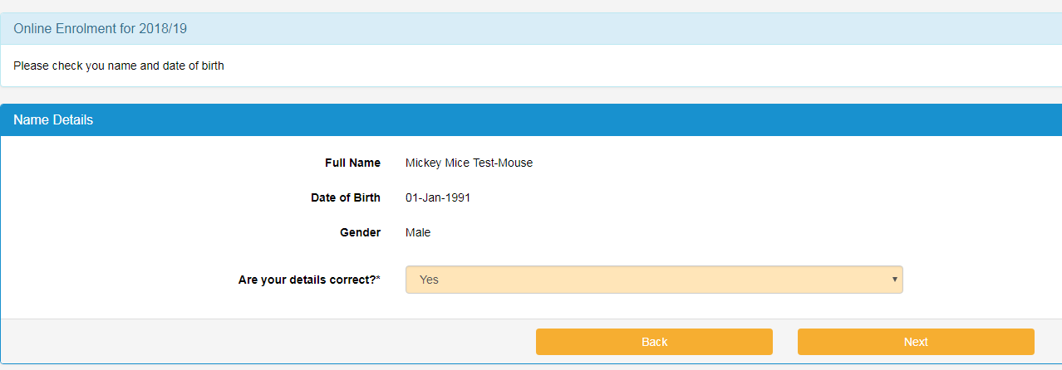

**Confirm the course:**

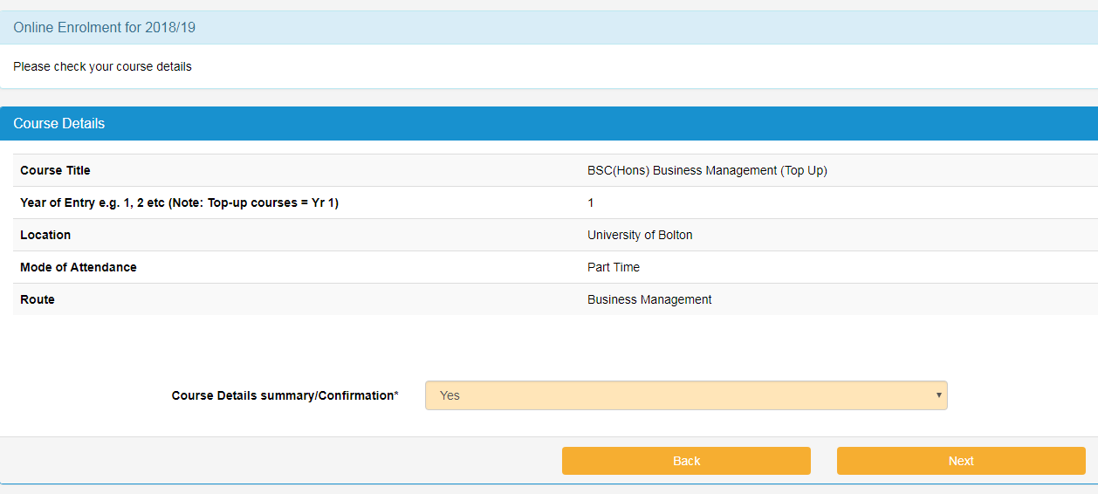

**Will you expect to finish the course by the end of July?**

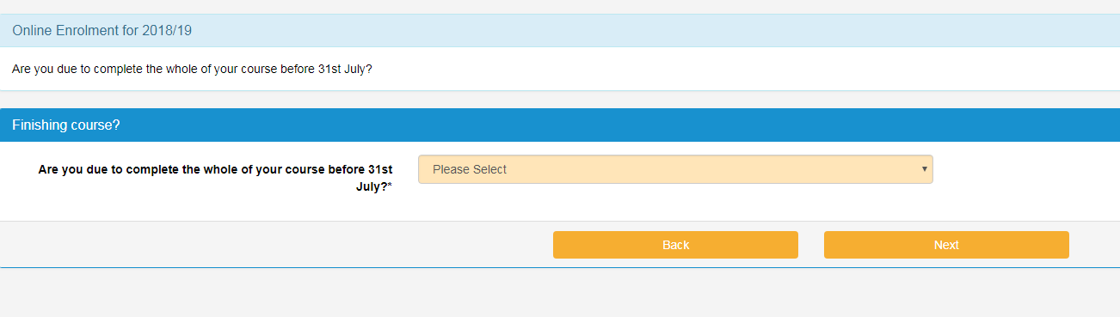

**Will you be studying for the whole of the academic year? No if studying a short course:**

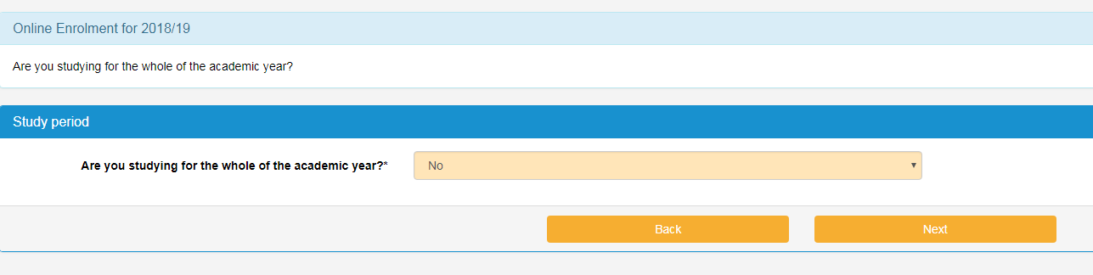

**Reason:**

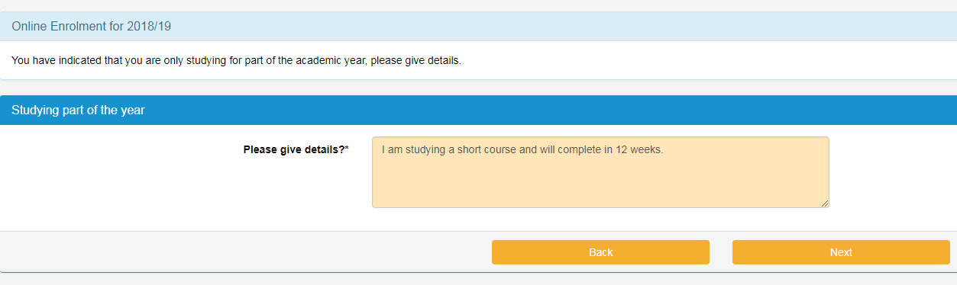

**Additional details:**

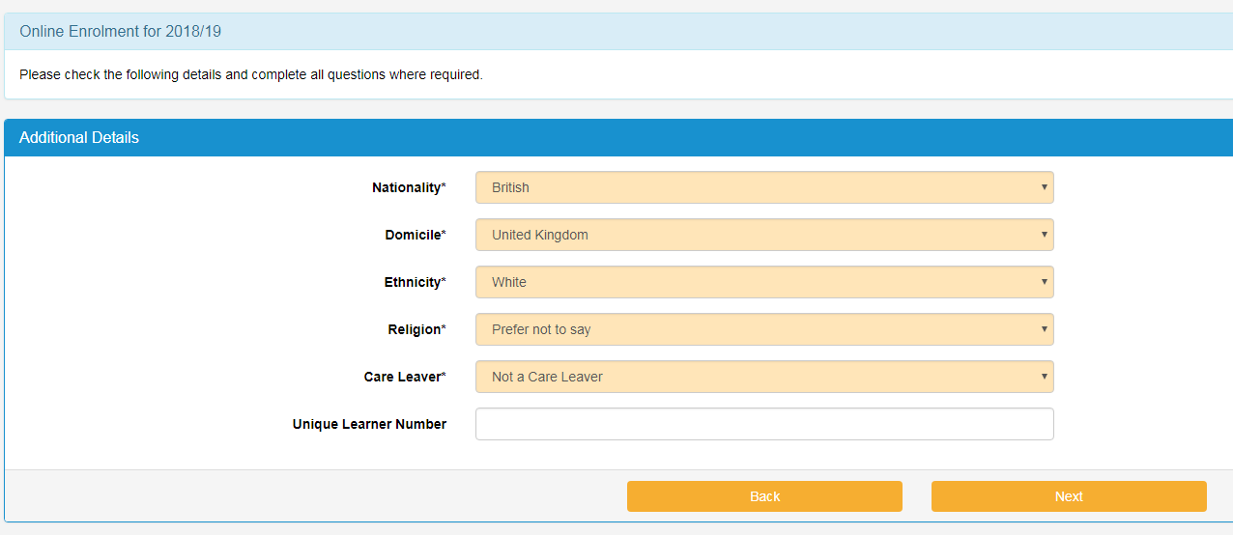

**Please leave the unique learner number blank if not known.**

**Add/Update contact information. Term time address is the address where you are staying whilst studying at university. This could be the same as the home address where you normally reside:**

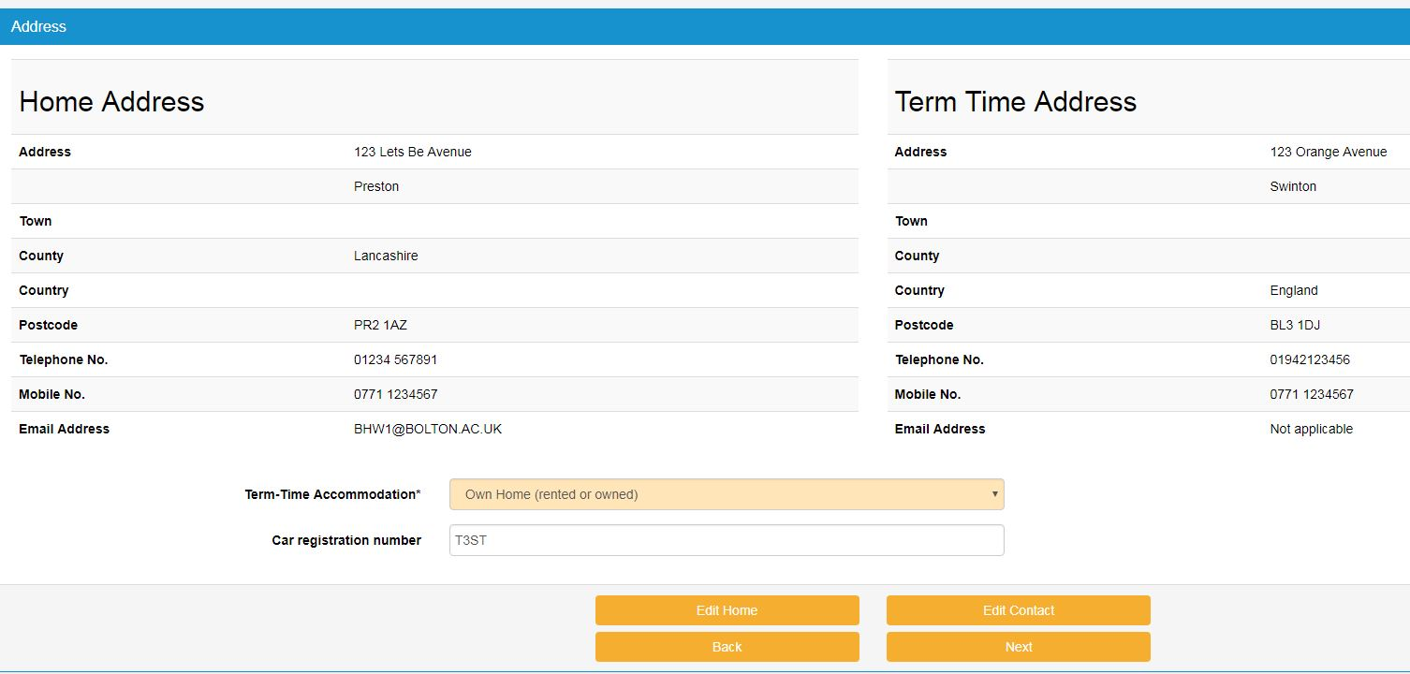

**Next of kin information:**

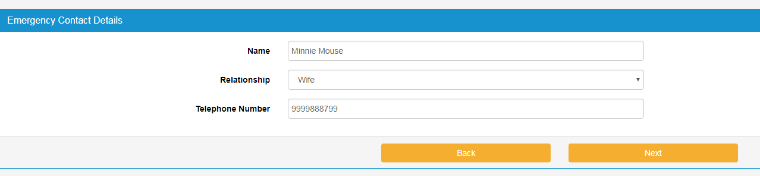

**Disability information:**

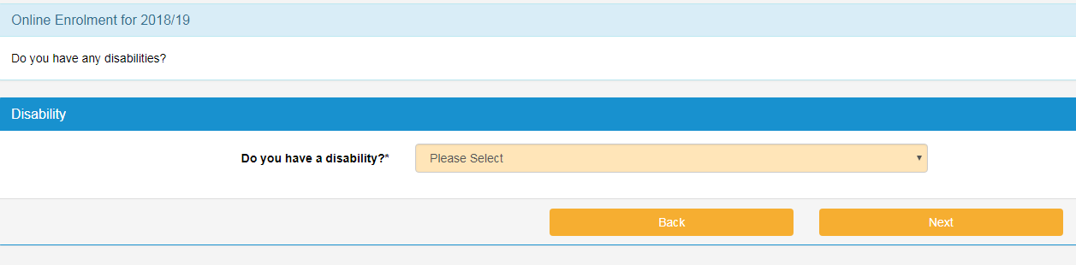

Occupation if you are 21 years old and over. Your parents/guardians occupation (who earns the most) if you are under 21.

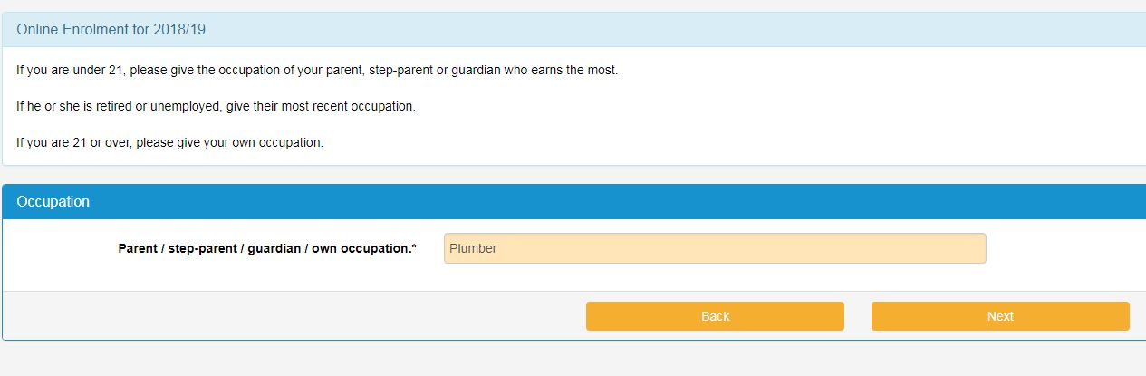

**Fee status questions:**

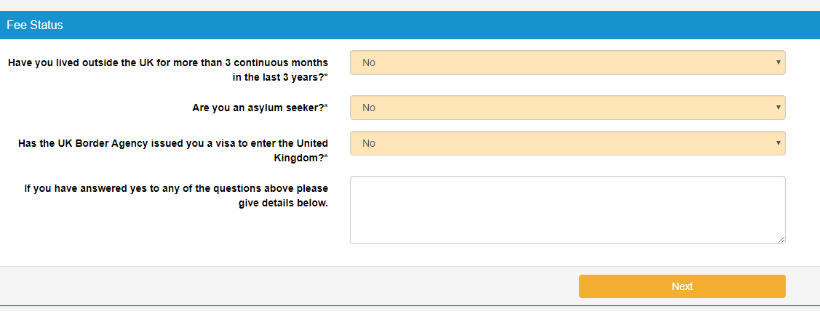

**Previous Higher Education Study?**

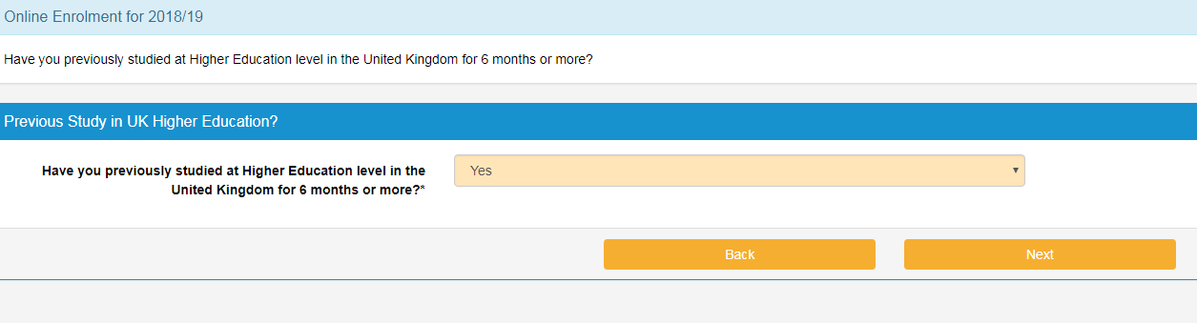

**Select your highest level qualification:**

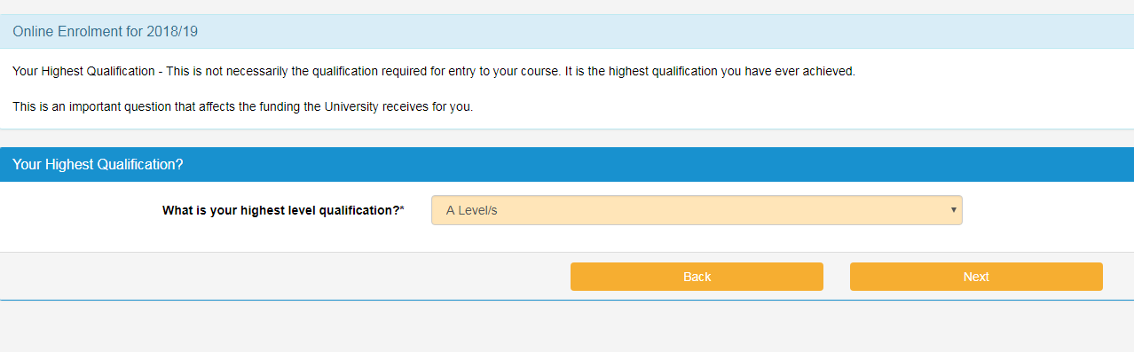

**Do any of your parents hold a higher education qualification?**

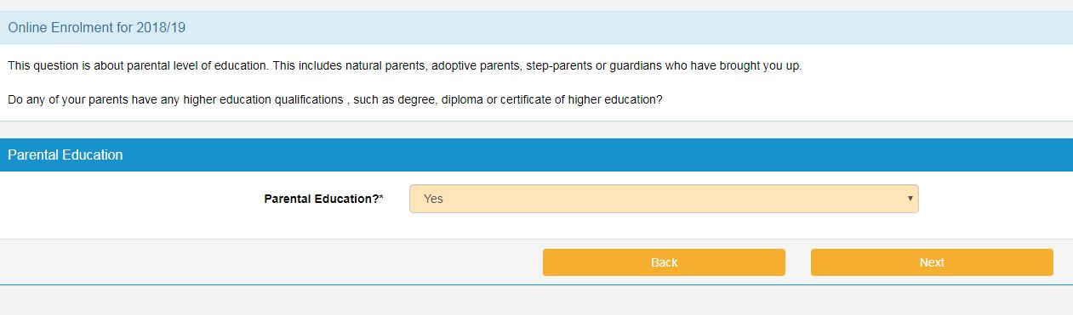

**Who is paying for the course?**

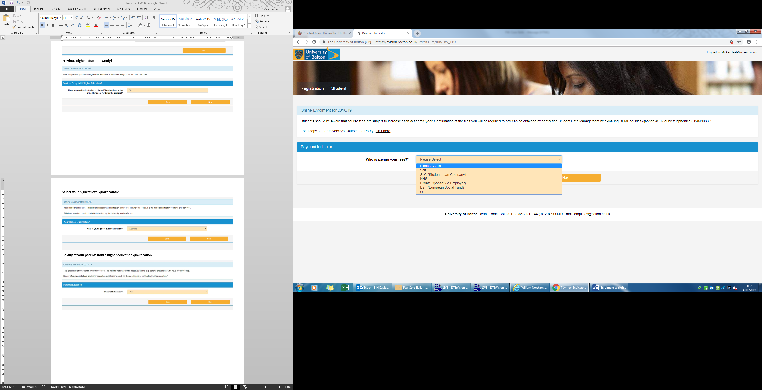

**Methods of payment:**

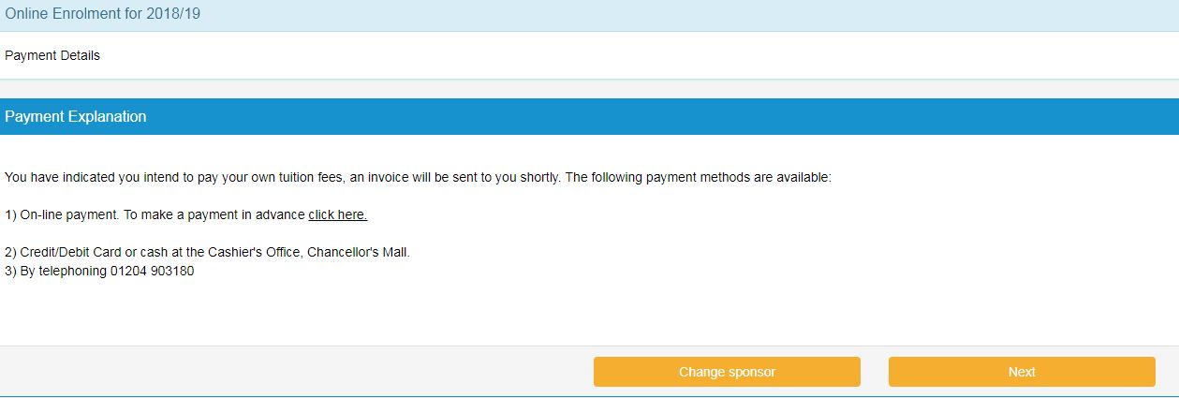

**Would you like us to share your basic contact information with our Graduate Recruitment Team and employment agencies?**

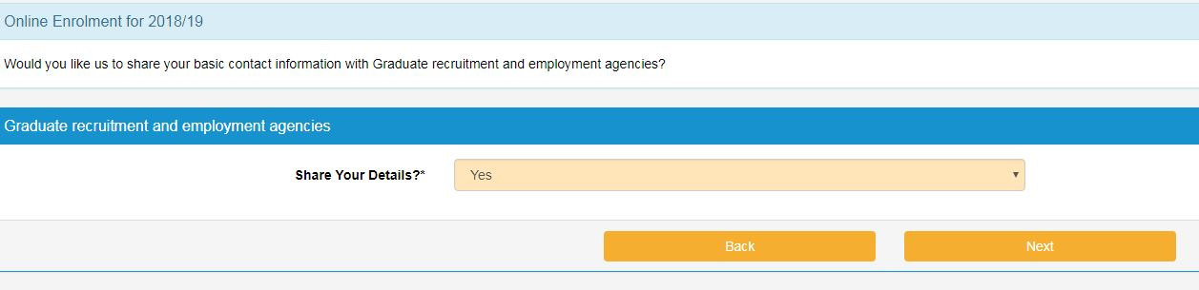

**Career questions:**

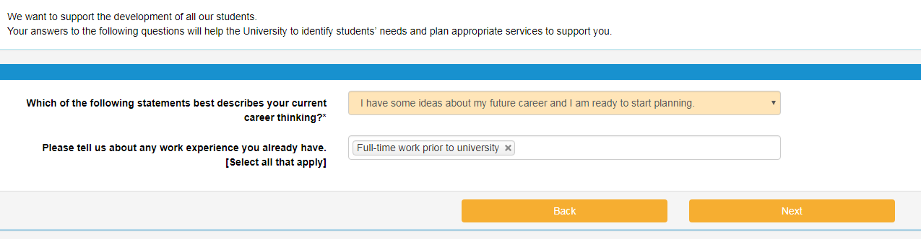

**The student will then be presented with the TERMS & CONDITIONS OF ENROLMENT FOR 2018/19 which they must read and decide if they wish to agree to them and continue.**

**If agreed and they proceed to the next screen they will be enrolled on the course.**

**They must then print the enrolment form, sign it and attend an ID verification session.**