Programme Handbook

BSc (Hons) Criminological and Forensic Psychology

Full-time/Part-time
2020-21

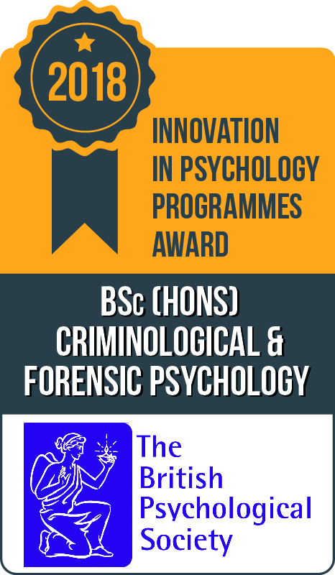

Frequent reference is made throughout this Programme Handbook to University of Bolton policies, procedures, regulations and guidance which apply to you. Parts of these are sometimes summarised here for your benefit. In all cases, these summaries are subject to the full University versions referred to. In the case of any conflict between the latter and any summaries presented here, it is the full University versions which apply.

Table of Contents
Contents
Welcome 4
1. Programme Details, Calendar and Timetable 5
1.1 Programme Overview 5
1.2 Programme Aims 6
1.3 Programme Structure and Module Tutors 7
1.4 Programme Calendar 8
1.5 Programme Timetable 8
1.6 Assessment Plans 8
1.7 Professional Body Recognition, Personal Development, Graduate Attributes Development 9
1.8 Higher Education Achievement Record (HEAR) 10
2. Communications and Attendance 11
2.1 Communication Systems 11
2.2 Contacting Staff 12
2.3 Programme Staff 12
2.4 Information about University Offices 15
2.5 Attendance and Engagement 16
3. Student Support 16
3.1 Programme Support 16
3.2 Other Student Support 17
3.3 Support for Students with Disabilities 19
3.4 Support for Part-Time Students 19
3.5 Careers Support 20
4. The Student Voice 22
4.1 Student Representatives and Committees 22
4.2 Programme Feedback 22
4.3 The Students’ Union 23
5. Learning Resources 23
5.2 Library Support 25
5.3 LEAP Online 25
6. Mitigating Circumstances, Academic Appeals Complaints and Report & Support 26
6.1 Mitigating Circumstances 26
6.2 Academic Appeals 26
6.3 Complaints 27
6.4 Report & Support 27
7. Health and Safety 27
7.1 On Campus Health and Safety following the Coronavirus Pandemic 27
7.2 Safeguarding and Prevent 28
7.3 First Aid on Campus 28
7.4 Accident Reporting on Campus 29
7.5 Fire Evacuation Procedure on Campus 29
7.6 Smoke Free Policy on Campus 30
8. Environmental Sustainability 30
9. The Role of the External Examiner 30

Welcome

Welcome to the 2020-21 academic year at the University of Bolton
This Programme Handbook has been produced to provide you with useful information which you will need during your studies. It includes details about your programme, key contacts, the support available, as well as information about how you can help us to improve your University experience.

As a teaching intensive, research informed University, we aim to provide you with a unique curriculum that is contemporary, stimulating, employment-focused and informed by the latest research in your discipline. Student success is at the heart of everything we do at this University. You will receive customised support ranging from study skills development to personalised assignment feedback. You will be presented with opportunities to pursue your areas of interest, develop employability skills and achieve your life goals.

We have created an environment which is designed to enable you to excel and succeed. Your tutors are well qualified and committed to your success. This is an excellent opportunity for you to realise your potential in partnership with the University and its staff. This will require you to make the time to engage in scheduled sessions and undertake independent learning activities, as well as take advantage of the wide range of support available and participate in extra-curricular activities.

I would like to wish you every success in your studies.

Dr Kondal Reddy Kandadi
Deputy Vice-Chancellor

A Welcome from the Dean of Faculty of Professional Studies

Welcome to the School of Education and Psychology, that sits within the Faculty of Professional Studies. This is the home of Psychology. We have a simple aim – and that is to equip you with opportunities to study for the qualifications which will prepare you for the best jobs in your field. We can be confident in this aim, because each of our programmes provides academic perspectives alongside experience-based insights from the professional field.

I’d like to take this opportunity to wish you every success in your studies and am confident that you will enjoy your time studying within the School.

Dr Gill Waugh
Dean

1. Programme Details, Calendar and Timetable

1.1 Programme Overview
Welcome to the University of Bolton and the BSc (Hons) Criminological and Forensic Psychology programme. This programme is concerned with the study of offending behaviour, from both offenders’ and victims’ perspectives. You will be given a strong foundation in the theories and practice of psychology, with a focus on forensic theories, such as theories of aggression, sexual offending, terrorism, and delinquent behaviour. You will study legal psychology and psychology of the courts, including interviewing techniques used by the police and issues around court testimony. You will be encouraged to apply psychological theories to relevant areas, such as stalking, domestic violence, and assessing risk of future aggression. The course will equip you with the knowledge and understanding for a range of careers, including the prison service, health, police, probation service, victim support services, and services targeting families of offenders or victims. Graduates will also be able to go on to further study.

The BSc (Hons) Criminological & Forensic Psychology degree course has been accredited as conferring eligibility for the Graduate Basis for Chartership (GBC) of the British Psychological Society (BPS) provided the minimum standard of qualification is achieved. In order to be eligible for Graduate Basis for Chartered Membership (GBC), all students must pass PSC6001 The Honours Project. In addition, students must gain at least a Lower Second Class Honours degree.

This undergraduate degree is delivered and assessed at levels 3, HE4, HE5 and HE6 and complies with the Assessment Regulations for Undergraduate Programmes. These are accessible via the Student Information-Policy Zone on the web:
https://www.bolton.ac.uk/about/governance/policies/student-policies/

1.2 Programme Aims

The aims of the programme are as follows:
- To introduce students to a wide range of perspectives in modern psychology;
- To introduce students to key conceptual issues and controversies in psychology;
- To develop students’ skills of empirical investigation;
- To sensitise students to ethical issues and their appropriate resolution in psychological research;
- To develop an understanding of a range of applications of psychology;
- To develop students' powers of critical analysis and evaluation;
- To develop students' transferable skills;
- To encourage independent learning in psychology.
- An appreciation of how subject specific knowledge and practice is applied in a forensic setting.
You will see from these aims that we wish to emphasise the diversity of psychology and to support your interests, skills and understanding across many areas and facets of the discipline.

1.3 Programme Structure and Module Tutors

Module and Weblink | Module No. | Core/ Option | Credits | Module Tutor*
HE4
Understanding the Person  http://modules.bolton.ac.uk/modules/PSC4009/Academicyear/2019-20 | PSC4009 | Core | 20 | Dr Nadhim Al-Talib
Applications in Psychology  http://modules.bolton.ac.uk/modules/PSC4011/Academicyear/2019-20 | PSC4011 | Core | 20 | Tara Chandler
Contemporary Issues in Psychology  http://modules.bolton.ac.uk/modules/PSC4010/Academicyear/2019-20 | PSC4010 | Core | 20 | Tara Chandler
Introduction to Research Methods in Psychology  http://modules.bolton.ac.uk/modules/PSC4001/  Academicyear/2019-20 | PSC4001 | Core | 20 | Dr Jacqui Harrison
Cognitive and Biopsychological Perspectives  http://modules.bolton.ac.uk/modules/PSC4003/Academicyear/2019-20 | PSC4003 | Core | 20 | Dr Pedro Vital
Psychology and Crime  http://modules.bolton.ac.uk/modules/CFP4001/Academicyear/2019-20 | CFP4001 | Core | 20 | Dr Gill Brown
HE5
Cognitive Psychology  http://modules.bolton.ac.uk/modules/PSC5004/Academicyear/2019-20 | PSC5004 | Core | 20 | Dr Sharon Preston
Biopsychology  http://modules.bolton.ac.uk/modules/PSC5005/Academicyear/2019-20 | PSC5005 | Core | 20 | Dr Richard Jagger
Social and Critical Psychology  http://modules.bolton.ac.uk/modules/PSC5006/  Academicyear/2019-20 | PSC5006 | Core | 20 | Dr Jacqui Harrison
Psychology of Law and Justice  http://modules.bolton.ac.uk/modules/CFP5001/Academicyear/2019-20 | CFP5001 | Core | 20 | Dr Gill Brown
Personality and Developmental Psychology  http://modules.bolton.ac.uk/modules/PSC5011/Academicyear/2017-18 | PSC5011 | Core | 20 | Dr Sharon Preston
Research Methods in Psychology  http://modules.bolton.ac.uk/modules/PSC5007/Academicyear/2019-20 | PSC5007 | Core | 20 | Dr Jacqui Harrison
HE6
The Honours Project  http://modules.bolton.ac.uk/modules/PSC6001/Academicyear/2019-20 | PSC6001 | Core | 40 | Dr Michelle Lowe
Applied Experience  http://modules.bolton.ac.uk/modules/PSC6020/Academicyear/2019-20 | PSC6020 | Core | 20 | Jo Luckhurst
Abnormal Psychology  http://modules.bolton.ac.uk/modules/PSC6006/Academicyear/2019-20 | PSC6006 | Core | 20 | Sue Prynn
Applications in Forensic Psychology  http://modules.bolton.ac.uk/modules/CFP6001/Academicyear/2019-20 | CFP6001 | Core | 20 | Dr Gill Brown
Psychology of Loss and Trauma  http://modules.bolton.ac.uk/modules/PSC6008/Academicyear/2019-20 | PSC6008 | Optional | 20 | Dr Michelle Lowe
Cyber Psychology and New Media  http://modules.bolton.ac.uk/modules/PSC6018/Academicyear/2019-20 | PSC6018 | Optional | 20 | Dr Julie Prescott
Psychology in the Workplace  http://modules.bolton.ac.uk/modules/PSC6023/Academicyear/2019-20 | PSC6023 | Optional | 20 | Pauline Matthews
* Please see section2.3 for Module Tutor contact details

1.4 Programme Calendar

A link to the University’s Academic Calendar is provided below:
https://www.bolton.ac.uk/staff-area/academic-calendars/

1.5 Programme Timetable
A link to your timetable is provided below:
https://www.bolton.ac.uk/Timetables/Home.aspx

1.6 Assessment Plans

*Please note specific dates could be subject to change. Any changes will be communicated clearly with students in advance

Module | Semester | Assessment | Submission Deadline
PSC6001: The Honours Project | S1 & S2 | 1 Coursework | S2 Week : 12 date 26/04/21  Ongoing throughout S1 &2
PSC6020: Applied Experience | S1 & S2 | 1 Portfolio | S2 Week 9 : date 22/03/21  Ongoing throughout S1 &2
PSC6006: Abnormal Psychology | S1 | 1 Coursework | Week 13 : date 18/12/20
CFP6001: Applications in Forensic Psychology | S1 | 1 Coursework  2 Presentation | Week 7 : date 04/11/20  Week 13 : date 14/12/20
PSC6008: Psychology of Loss, Trauma (optional) | S2 | 1 Coursework  2 Presentation | Week : 8 date 15/03/21  Week : 14 date 10/05/21
PSC6018: Cyber Psychology and new media (optional) | S2 | 1 Coursework  2 Presentation | Week : 6 date 04/03/2021  Week : 14 date 13/05/2021
PSC6023: Psychology in the Workplace (optional) | S2 | 1 Coursework  2 Presentation | Week 9: date 24/3/2021  Week 14: date 12/05/2021

1.7 Professional Body Recognition, Personal Development, Graduate Attributes Development

The programme is accredited by the British Psychological Society: http://www.bps.org.uk/ and in 2018 this programme was awarded the national BPS award for Innovation in Psychology programmes. During your studies you will have the opportunity to hear lectures from experts across a range of disciplines from the criminal justice field and take part in applied workshops. The University of Bolton has recently signed a Memorandum of Understanding with Greater Manchester Police (http://www.bolton.ac.uk/MediaCentre/Articles/2015/Sep2015-10.aspx), further widening opportunities for student placements, research and practical project opportunities.

As a graduate in BSc (Hons) Criminological and Forensic Psychology, you will have a range of career options to pursue within a variety of settings. Your studies and the range of practical assessments delivered throughout your period of study, but in particular the applied experience module, will ensure that you have a competitive advantage over others graduating with similarly named programmes elsewhere. Opportunities for graduates exist in the private, public and voluntary sectors. In addition, the fact that this course is BPS accredited means that you can enrol on a MSc to progress towards becoming a Forensic Psychologist, or enrol on a counselling or clinical doctorate. You can obtain guidance and assistance from the University of Bolton’s Careers Service team and take advantage of the resources they have to help you in your search for a career.

Graduate Attributes Matrix for Employability (GAME)
Graduate attributes are the personal qualities, skills and academic abilities that are valued by the University of Bolton community, and that a student should acquire during their time at the University. Graduate attributes can be developed as part of a programme of study, as well as through the wider student experience.

Graduate attributes are:
- Expressive of what it means to be a University of Bolton graduate
- Not simply taught in the classroom but fostered through meaningful experiences and as a result of continuous learning and reflection
- Unique to every student – in terms of his or her starting point, experiences, development and comprehension.

Graduate attributes provide a platform for engaging with the world of work. They act as a point of reference for a student’s personal development and support the articulation of employability and transferable skills. In this context, the following 10 core graduate attributes are embedded in each programme of study and serve as the fundamental skills framework for University of Bolton students:
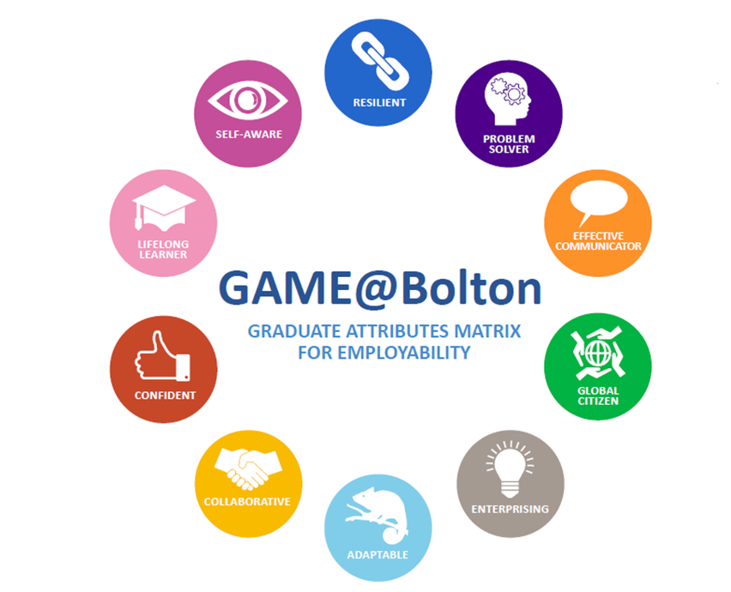

1.8 Higher Education Achievement Record (HEAR)
The HEAR is an extended degree transcript, providing students with a comprehensive record of their University learning and experience – both academic and co-curricular. Students will have a HEAR if they are aiming for an undergraduate degree, a taught postgraduate degree, or a range of additional certificate and diploma qualifications. Students eligible for a HEAR will receive an invitation email from Gradintelligence (accountregistration@gradintel.com), the University’s technology partner which provides the web portal where students can view and share their HEAR. The Gradintelligence account must first be activated before use.

The HEAR includes a student’s programme aims and objectives; module marks and grades; qualification result; grading and classification scheme; plus any professional, statutory and regulatory body recognition. It also includes any University, School and professional body prizes awarded.

Any University-approved achievements undertaken outside the course curriculum will also be added, e.g. the Bolton Award, Volunteering, Students’ Union Society positions, Student Representative roles, University Board/ Committee/Panel membership, as well as in due course Peer Mentoring, Peer-Assisted Study Skills tutoring and Student Ambassador work. Over time, the range of achievements which can be recorded on a HEAR will increase. Further details are available at: https://www.bolton.ac.uk/hear/ under ‘Additional Recognised Achievements’.

Students can use their HEAR to help them review progress and plan what they want to achieve at University, e.g. with their Personal Academic Tutor or a Careers Advisor. Through the Gradintelligence web portal, students can share their HEAR with employers and others whilst at University and afterwards, to provide evidence of achievements at University.

Any queries or problems about the HEAR that cannot be resolved by visiting the website at https://www.bolton.ac.uk/hear/ or by asking a tutor, can be sent via email to: hear@bolton.ac.uk.

2. Communications and Attendance

2.1 Communication Systems
Communication to individual students is usually through email. As a policy, University staff will only respond to emails sent from a student’s University Outlook account. This is to ensure that data protection legislation is complied with.

A University Outlook account can be set up to forward emails to a personal email address. See: http://www.bolton.ac.uk/ITSupportServices/Managing-Your-Email.aspx
Please note, however, that students will need to respond to any University emails using the University Outlook account. A student number should be included in the email.

Most Module Tutors will post announcements through the Moodle, the University’s virtual learning environment (VLE). It is important therefore that students familiarise themselves with how to access this electronic information.

In some cases, letters may be sent to a student’s local or home address. It is important to ensure that student details are therefore kept up to date on the student record.

Useful web addresses:
- University of Bolton website: www.bolton.ac.uk
- University of Bolton Student Area: https://www.bolton.ac.uk/student-area/
- University of Bolton Student Record: https://evision.bolton.ac.uk/urd/sits.urd/run/SIW_LGN
- University of Bolton Library: www.bolton.ac.uk/library
- University of Bolton Moodle: https://moodle.bolton.ac.uk/
- University of Bolton Student Support Live Chat Ask Us: https://www.bolton.ac.uk/student-life/student-support/student-services/ask-student-services/
- British Psychological Society: https://www.bps.org.uk/

We also post news items on facebook: https://www.facebook.com/UniversityofBolton and Twitter: @BoltonUni

2.2 Contacting Staff
The best way to contact staff is by email. Staff will endeavour to respond to emails within two full working days. If a face-to-face discussion is required, students may arrange a mutually convenient appointment with their Programme Leader, Module Tutor or Personal Academic Tutor.

2.3 Programme Staff
The table below identifies programme staff together with their locations and contact details.
Staff name | Position | Location | Tel. | Email (all to be followed by @bolton.ac.uk)
Dr Gill Brown  https://www.bolton.ac.uk/dr-gill-brown | BSc(Hons) Criminological and Forensic Psychology Programme Leader/ Associate Teaching Professor | T2-38 | 3686 | G.Brown@bolton.ac.uk
Dr Nadhim Al Talib  https://www.bolton.ac.uk/dr-nadhim-al-talib | BSc(Hons) Psychology Programme Leader/ Academic Operational Lead for Psychology | T2-44 | 3148 | NA3
Steven Barnes  https://www.bolton.ac.uk/steven-barnes-2 | Course Tutor in Psychology | T2-42 | 3662 | S.Barnes
Prof Jerome Carson  https://www.bolton.ac.uk/prof-jerome-carson | Professor of Psychology | T2-34 | 3228 | JFC1
Charlotte Conn | Associate Lecturer |  |  | C.Conn
Mel Greenhalgh  https://www.bolton.ac.uk/mel-greenhalgh | PG Diploma CBT Therapy Programme Leader | T2-46 | 3508 | MG12
Dr Jacqui Harrison  https://www.bolton.ac.uk/dr-jacqui-harrison | Academic Co-Ordinator for Recruitment and Retention/ Senior Lecturer | T4-06 | 3696 | JH22
Mark Hill  https://www.bolton.ac.uk/mark-hill | Lecturer | T2-46 | 3468 | MH3
Dr Richard Jagger  https://www.bolton.ac.uk/dr-richard-jagger | Lecturer | T2-36 | 3146 | R.Jagger
Chathurika Kannangara  https://www.bolton.ac.uk/chathurika-kannangara | MSc Counselling and Positive Psychology programme leader/ Associate Teaching Professor | T2-40 | 3306 | CK3
Tara Chandler  https://www.bolton.ac.uk/tara-chandler | Lecturer | T2-24 | 3142 | T.Kelly
Dr Michelle Lowe  https://www.bolton.ac.uk/dr-michelle-lowe | Reader in Psychology | T2-38 | 3760 | Michelle.Lowe
Jo Luckhurst  https://www.bolton.ac.uk/jo-luckhurst | Lecturer | T2-30 | 3677 | J.Luckhurst
Pauline Matthews  https://www.bolton.ac.uk/pauline-matthews | Senior Lecturer | T2-42 | 3908 | PMB1
Aashiya Patel  https://www.bolton.ac.uk/aashiya-patel | Associate Lecturer | T2-40 | 3359 | A.Patel2
Dr Julie Prescott  https://www.bolton.ac.uk/dr-julie-prescott | BSc (Hons) Psychology with Psychotherapy and Counselling Programme Leader/ Reader in Psychology | T2-40 | 3676 | J.Prescott
Dr Sharon Preston  https://www.bolton.ac.uk/dr-sharon-preston | Senior lecturer | T2-24 | 3150 | SP8
Sue Prynn  https://www.bolton.ac.uk/sue-prynn | Lecturer | T2-30 | 3662 | S.Prynn
Dr Pedro Vital  https://www.bolton.ac.uk/dr-pedro-vital | Masters’ Programme Leader | T2-36 | 3685 | P.Vital

2.4 Information about University Offices
Office | Location | Contact Details
Ask Us – Student Support Live Chat | Online | Website: https://www.bolton.ac.uk/student-life/student-support/student-services/ask-student-services/
Bolton Students’ Union | Chancellor’s Mall | Website: https://www.boltonsu.com/  Tel: 01204 900850  Email: info@boltonsu.com  Twitter: @Bolton_SU
Careers Service | Chancellor’s Mall | Website: https://www.bolton.ac.uk/careers/  Tel: 01204 903080  Link for appointments: https://studenthub.bolton.ac.uk  Twitter: @boltoncareers
Disability Service | Chancellor’s Mall  via Student Centre | Website: https://www.bolton.ac.uk/studentservices/disability/  Tel: 01204 903067  Email: disabilityinfo@bolton.ac.uk for queries & appointments
IT Help Desk | Peter Marsh Library | Website: https://itsupport.bolton.ac.uk/Login.jsp?navLanguage=en-US  Tel: 01204 903444
Life Lounge | T2 – Eagle Tower | Website: https://www.bolton.ac.uk/student-life/student-support/life-lounge/  Tel: 01204 903566  Email: lifelounge@bolton.ac.uk for queries & appointments
Mental Health Advisors | Chancellor’s Mall via Student Centre | Tel: 01204 903067  Email: MHAdvisor@bolton.ac.uk  Email: lifelounge@bolton.ac.uk for appointments
Peter Marsh Library | Chancellor’s Mall via SLZ | Website: https://www.bolton.ac.uk/library/Home.aspx  Tel: 01204 903094  Twitter: @BoltonUniLib
Sport and Wellness | Bolton One | Website: https://www.bolton.ac.uk/student-life/sport-and-wellness/  Tel: 01204 903172  Email: sportscentre@bolton.ac.uk
Student Centre – Student Advisors | Chancellor’s Mall | Website: https://www.bolton.ac.uk/studentservices/studentadvisors/  Tel: 01204 903733  Email:studentadvisors@bolton.ac.uk for queries & appointments
Student Hub &  Student Liaison Officers | D1- Senate House | Website: https://www.bolton.ac.uk/student-life/student-support/student-liaison-officers/  Tel: 01204 903229 or 01204 903489  Email: SLO@bolton.ac.uk
University Main Reception/  General Enquiries | Senate House | Tel: 01204 900600  Email: enquiries@bolton.ac.uk

2.5 Attendance and Engagement
In order to progress and achieve the award for which they are registered, students must attend all scheduled sessions. The University attendance and engagement policy is located at:
https://www.bolton.ac.uk/about/governance/policies/student-policies/

Please note that attendance and/or engagement is taken into account when making Assessment Board decisions.

Students may be withdrawn due to poor attendance and/or engagement

3. Student Support

3.1 Programme Support

Programme Leader
Programme Leaders are responsible for the organisation and management of a programme. They oversee the scheduling and delivery of modules, support programme developments, co-ordinate marketing and recruitment activities, and ensure programme quality standards are maintained.

Module Tutor
Module Tutors are academics who are responsible for the organisation and delivery of a particular module. Module Tutors also design and mark module assessments. If there is an academic problem with a specific module, the first point of contact should always be the Module Tutor. If the query is not resolved, students should contact their Programme Leader or Student Representative.

Personal Academic Tutor
The University of Bolton operates a proactive Personal Academic Tutoring scheme to support students’ personal, professional and academic development. Personal Academic Tutors are members of the academic team within a School and provide support for students with their transition into and through the University journey.

Students are allocated a Personal Academic Tutor prior to their arrival at the University. Personal Academic Tutors act as a student’s first port call to advise on academic and pastoral matters and to signpost students to other services as required.

Peer Support
It is important that students build networks of friends and course mates during their studies. Having the right support from fellow students can make a big difference to life at University and can help students to learn more effectively. To enhance support from experienced students, the University operates peer (student to student) support schemes on a one to one basis. A group scheme, involving Peer Assisted Study Sessions (PASS) may also be available. Students can contact their personal academic tutor, the Student Liaison Officers or Peer Support Coordinator, for further information.

Enhanced Personal Academic Tutors
Each School has a group of Enhanced Personal Academic Tutors (EPATs) who oversee personal academic tutoring and ensure that students get the right help and support they need. Enhanced Personal Academic Tutors will also co-ordinate the PASS schemes mentioned above.

3.2 Other Student Support

Student Services
The Student Services team is based in the Student Centre, Chancellor’s Mall. There is also a satellite service at Queen’s Specialist Building and the Institute of Management, which operates at specified times from the Student Information Centre on the ground floor. Student Services is staffed by Student Advisors and specialist support staff who provide information, advice and guidance to students (current, past and prospective) and staff.

Student Advisors are the first point of contact for the following services:
- Academic Advice and Guidance - General academic advice, Mitigating Circumstances (see Section 6.1), Appeals (see Section 6.2), Complaints (see Section 6.3) timetable queries, module choices, suspending studies, withdrawing from the University.
- Documentation - Bank letters and official letters, Council Tax exemptions, Student ID Cards.
- Other services - Accommodation including the Halls of Residence, Chaplaincy, Counselling, Disability Service (see Section 3.3), Disclosure and Barring Service, Immigration and Welfare, Student Funding and Hardship Fund.

Life Lounge
The Life Lounge currently operates a range of specialist mental health and wellbeing services, which are free for students to access. The Life Lounge Team comprises the Mental Health Advisor Service, the Student Counselling Service, Cognitive Behavioural Therapy (CBT) clinic, which is overseen by the team’s qualified CBT therapist, a Wellbeing Coordinator and Wellbeing Advisor. The team offer dedicated mental health and wellbeing provision to any student in need of support during their course of study; including one to sessions, workshops and online support resources.

The Life Lounge also offers students a quiet place to go to relax away from other distractions on campus. Specialist external partners also use the Life Lounge, working in collaboration with Life Lounge staff, in order to complement the support available for students.

The Hub
The Hub, in Senate House, is home to the Student Experience Team and is located on the ground floor of Senate House. The Hub consists of three zones which can be used for small group or individual study. There is also a learning zone where the Student Liaison Officers (SLOs) run LEAP study skills workshops. LEAP study skills workshops are listed under the events tab on the Student Hub webpages https://studenthub.bolton.ac.uk.

The Multi-faith Chaplaincy
Revd Dr Gill Smart is the University Co-ordinating Chaplain and works with a team of Chaplains and pastoral assistants of different faiths.

The multi-faith Chaplaincy can be found at the back of the Chancellors Mall, just past the SLZ and the Athena Café and is for all students, both those of faith and no faith. Chaplains and pastoral assistants are always ready to talk, in confidence, if students have any concerns over any aspect of their life. The multi-faith Chaplaincy won’t judge and won’t talk about religion/faith unless asked to. A virtual meeting can be arranged via Zoom if preferred.
Revd Dr Gill Smart was an academic staff member in the School of Engineering so she understands the pressures that students experience, especially when assessment and exam times come round. Students are welcome to call in and have a chat. Gill can be contacted via email on chaplain.gill@bolton.ac.uk or telephone or text 07967 585670.

Students’ Union Advice Unit
Bolton Students’ Union has an independent Advice Unit based within the Students’ Union Office. The Advice Unit offers free, impartial and confidential advice to all University of Bolton students on academic issues, such as Appeals, Mitigating Circumstances, Complaints and Academic Misconduct, as well as on issues such as money concerns, problems with accommodation and housing. To arrange a chat, students can call into SU Office in Chancellor’s Mall or email on info@boltonsu.com.

3.3 Support for Students with Disabilities
The University of Bolton welcomes students with disabilities and/or additional support requirements and will make every effort to support their needs. The Disability Service provides specialist advice and guidance to disabled students including those with physical and sensory impairments, mental health concerns, medical conditions and Specific Learning Disabilities (SpLD) which have a severe impact on day to day activities or life at the University.

Disability Advisors are available to discuss the individual adjustments students need based on the evidence provided. The service offers bookable appointments as well as drop in sessions, throughout the week; details of which are available from the Student Centre.

Student Services staff can offer online appointments via Zoom or MS Teams, please email the relevant team to organise this. Students can also chat with staff on Ask Us (https://www.bolton.ac.uk/student-life/student-support/student-services/ask-student-services)

3.4 Support for Part-Time Students
Part-time students can follow their programme in the same way as full-time students. However, attendance is restricted to a maximum number of modules each academic year in order to maintain part-time status. Students should contact their Programme Leader or Personal Academic Tutor to clarify their programme requirements.

Changing from part-time study to full-time study may be possible for those who have successfully completed the modules undertaken, providing the programme is offered on a full-time basis and full-time fees can be met. Students should contact their Programme Leader in the first instance if this is something they are considering.

3.5 Careers Support
Careers Service
The Careers Service supports students in planning their future careers and helps them to develop key skills and graduate attributes. Students may already know what career path they wish to follow, but alternatively, they may still be undecided at this stage.

The Careers team hosts a number of employability workshops and employer events, including an annual Careers and Opportunities Fair. They also advertise full and part-time job vacancies, placements and internships on the jobs portal which can be accessed at https://studenthub.bolton.ac.uk

The Careers Service helps students to look at a range of employment options and provides the resources to help them to succeed. The comprehensive support on offer includes:
- Bespoke careers advice and guidance with a professionally qualified Adviser
- Help in the preparation of job applications and cover letters
- Guidance on creating and improving a CV
- Access to full-time, part-time and vacation work opportunities
- Information on different career paths
- Information on a range of employers, both nationally and locally
- Support with finding a placement or graduate internship
- The opportunity to gain a range of employability skills and graduate attributes
- The chance to build contacts and networking opportunities
- The chance to explore further study.
- Access 24/7 to a wide range of digital and online resources

The Bolton Award
The Bolton Award is an employability and enterprise programme for all undergraduate and postgraduate students at the University of Bolton. It has been designed to enable students to benefit from work experience, skills development and a range of enrichment activities. Intended to be an achievement that is independent from academic studies, the Bolton Award is an extra-curricular programme, which requires a minimum commitment of 35 hours in total. It is free and can be completed at a convenient pace. Full support is also available. Please see: https://studenthub.bolton.ac.uk

4. The Student Voice

4.1 Student Representatives and Committees
In order to continuously improve the student experience, volunteer Student Representatives are selected to represent the voice of the student population on key committees. Student Representatives for every course level are elected annually and are then trained and supported throughout their term of office by Bolton Students’ Union.

The role of a Course Representative is to gather the views (what is working well and areas for improvement) from other students on their programme on academic matters and other elements of the student experience. These matters are then discussed at course level committees called Student-Staff Liaison Committees (SSLCs). SSLCs are usually chaired by a Programme Leader and comprise Module Tutors, as well as representatives from the Library and Administration teams.

School Representatives are also nominated from the pool of Course Representatives to sit on a School-wide committee called the School Board, which is chaired by the Head of School and comprises other academics and professional services staff. Representatives on these committees are expected to comment on school-wide matters.

Students interested in becoming Student Representatives will need to put themselves forward for election at the start of the academic year. Elected Student Representatives are then contacted by the Students’ Union and invited to a training session where they are given support and further information.

4.2 Programme Feedback
All students have the opportunity to contribute to the monitoring and enhancement of their course of study. Students can approach their Student Representative (see above), Programme Leader or Module Tutor on an informal level to discuss issues. The SSLC is also an important forum at which elected Student Representatives can speak on behalf of their peers.

In addition, students are asked to complete a satisfaction questionnaire for each module and an annual programme questionnaire. The programme questionnaire may be in the form of the National Student Survey, the UK Engagement Survey or the Postgraduate Taught Experience Survey, depending on their programme and level of study.

Survey feedback is important as it is used by the programme team and other services to enhance the provision and improve the student learning experience.

4.3 The Students’ Union

A Message from the SU President 2020-21: Ansh Sachdeva
Bolton Students’ Union is part of the National Union of Students (NUS). We work in partnership with both the University and the NUS to promote the Student Voice and to ensure that there are opportunities for all students to Love Student Life.

Bolton Students’ Union wants students to get involved by:

- Becoming an elected representative.
Students can be involved at different levels of academic delivery, by becoming a Course Representative, a School Board member or a programme approvals panel member.

Each year we run the Leadership Race (elections), where students can stand as candidates to lead the SU, as Student President, to represent the University at the NUS National Conference, and each year we appoint two students s full members of the SU Board of Trustees. All students at the University of Bolton are eligible to stand for election.

- Getting involved with our clubs and societies.
The SU supports over 30 academic, cultural and social student societies. Students can volunteer to become a Society Officer or even start their own society with our support! Societies offer opportunities to gain new skills through involvement with local and national NUS campaigns, other universities and organisations linked with the Students’ Union.

As an independent organisation, we can also offer impartial advice, guidance on and support for both personal and academic issues (see Section 3.2).

5. Learning Resources
The Library provides library and computing facilities with access to a wide range of information and learning resources.

The Library has plenty of resources online which students can access wherever they are – over 200,000 online books and over 55,000 online journals. Discover@Bolton allows students to search most of the resources via a single interface. Students can work quietly in the Peter Marsh Library, where there are also over 100,000 print books and over 200 print journals.

The library’s collections can be searched via www.bolton.ac.uk/library. Students can also check their library account and access online resources via the Library section of the MyBolton app.

Students will need their University of Bolton username and password to access online library resources.

Subject Guides provide a subject-specific overview of Library services and have been developed by Academic Librarians to highlight the most useful online and print resources for areas of study. Please see http://libguides.bolton.ac.uk/ - This is a great starting point for research for assignments!

Reading Lists Online (RLO) is an online service that allows students to access module reading lists. They can be accessed from Subject Guide web pages, the library homepage or from within Moodle. RLO enables access to e-resources such as eBooks, eJournals and databases directly from the list plus a direct link to the Library catalogue for availability and location of print titles. Students can create their own profile in RLO which gives extra functionality, such as adding notes to items in lists. The Library management team and specialist Academic Librarians liaise with teaching staff to ensure resources reflect current requirements and help provide users with the information they need. Priority is given to acquiring electronic resources, including e-books, to facilitate access off-campus.
For Bolton based students, there are PCs available throughout the Peter Marsh Library, as well as a self-service laptop-loan service for use in the Library and Social Learning Zone (SLZ). There are also open access computer facilities within the SLZ. The Library and SLZ are wireless enabled, together with hotspots throughout the campus, enabling students to connect their own mobile devices.

Several multi-functional machines within the Library provide printing, photocopying and scanning facilities with A4, A3, colour and black and white output. There is an initial free quota each semester and this can be topped-up online and at a print kiosk in the Library.

There are also PCs and printing facilities at the Queens Library and IoM Learning Resource Centre.
Students registered with the University as having a need for additional learning support, are able to benefit from a range of enhanced services, such as extended book loans and access to accessible versions of ebooks via RNIB Bookshare. In addition, assistive technology software is available on the network and, where appropriate, within specified rooms where specialist hardware is also available.

5.2 Library Support
When students enrol, they are automatically allocated library and computer accounts. New students should attend an induction to Library facilities within the first few weeks. As well as delivering inductions, the Academic Librarian team provides support to students in the form of user education classes, workshops and a range of help guides and videos which show how to access electronic books, journals and databases. Videos are available via the Library website and YouTube channel: https://www.youtube.com/user/BoltonUniLibrary. Students can also find answers to Frequently Asked Questions via the Library website and MyBolton app.

Students can get help with Library resources and services:
- In person at the Peter Marsh Library and Queens Library Helpdesks (during scheduled hours)
- By phone (during scheduled hours) on 01204 903094
- By online chat, available via the Library website, Monday to Friday https://www.bolton.ac.uk/library/
- By email: https://www.bolton.ac.uk/library/MailForms/Contact-the-Help-Desk.aspx

5.3 LEAP Online
LEAP Online is the University of Bolton’s award-winning interactive online tutorial which is designed to support students through their academic and personal development journey, with the emphasis on getting the most out of their time at University. The content can be used to help achieve academic and personal development goals.

Sections include My Student Engagement, My Academic Development, My Digital Literacy, and My Personal Development. It is packed with activities and assessments for students to complete and to work towards digital badges which demonstrate to their tutors that they have completed the section and have improved their knowledge and skills in areas such as referencing or time management.

If students are undertaking modules such as study skills or employability skills it is ideal to use in portfolios or as evidence of CPD/development. LEAP Online is located at: https://www.bolton.ac.uk/leaponline/Home.aspx
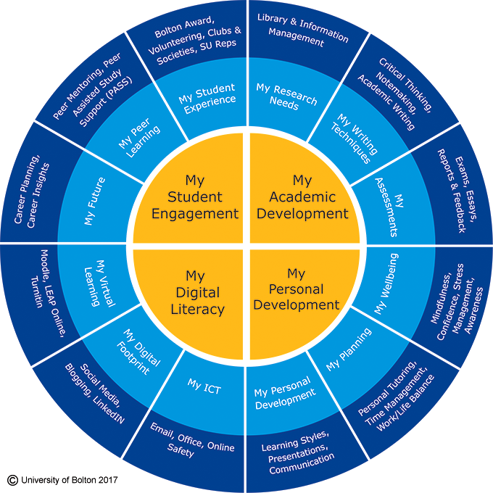

6. Mitigating Circumstances, Academic Appeals Complaints and Report & Support

6.1 Mitigating Circumstances
A Mitigating Circumstances request is one in which a student makes a case that their performance in assessment has been significantly and adversely affected by circumstances that are exceptional, unforeseen and/or outside of their control. Mitigating Circumstances requests must be presented prior to an Assessment Board and before the Mitigating Circumstances deadline specified.

Students who believe they have grounds for Mitigating Circumstances should contact their Personal Academic Tutor, Student Services or the SU Advice Unit.

For further details, see: https://www.bolton.ac.uk/about/governance/policies/student-policies/ Academic Regulations and Procedures and Additional Guidance and Forms.

6.2 Academic Appeals
Academic appeals may be submitted following an Assessment Board (and before the appeals deadline specified) if a student believes that:
- Circumstances affected his/her performance which, for good reason, the Assessment Board may not have been made aware of when making assessment decisions, or
- there was a material administrative error or procedural irregularity in the assessment process; or
- there is evidence of prejudice or bias or lack of proper assessment on the part of one or more of the tutors/assessors

Please note: An appeal which questions the academic or professional judgement of those charged with the responsibility for assessing a student’s academic performance or professional competence will not be accepted.

Students who believe they have grounds for an Appeal should contact their Personal Academic Tutor, Student Services, SLOs or the SU Advice Unit for advice. Appeal forms should be submitted to: appeals@bolton.ac.uk.

For further details, see: https://www.bolton.ac.uk/about/governance/policies/student-policies/
Academic Regulations and Procedures and Additional Guidance and Forms.

6.3 Complaints
The University welcomes comments and suggestions about how things might be improved, we also recognise that students and others with a legitimate interest have a right to complain if they feel that something is wrong.

Student Services and the SU Advice Unit can help to advise students on the procedure for making a formal complaint, including whether other procedures are more appropriate. Further details can be found at: https://www.bolton.ac.uk/about/governance/policies/student-policies/
Student Complaints Procedure, Guidance and Forms 2020-21

6.4 Report & Support
Students are able to report cases of harassment, bullying, discrimination and victimisation to the University where the perpetrator is a University of Bolton student, member of staff, visitor or contractor. More information is available in the Students' Dignity at Study Policy and Procedure (https://www.bolton.ac.uk/student-policy-zone/). Students can report any cases using the following Report and Support Form - https://www.bolton.ac.uk/student-life/student-support/student-complaints-procedure/report-and-support-form/

7. Health and Safety

7.1 On Campus Health and Safety following the Coronavirus Pandemic
Whilst there are continued arrangements in place in relation to on-campus learning, students should adhere to the Coronavirus updates on the web for additional health and safety guidance. Please see
https://www.bolton.ac.uk/student-area/student-coronavirus-update/
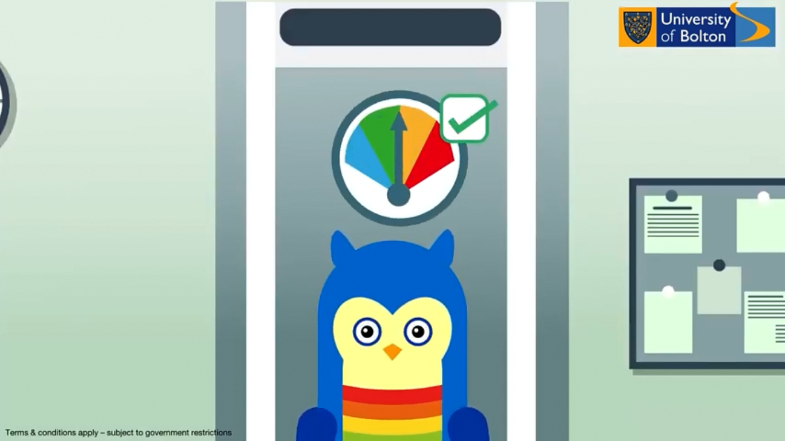

7.2 Safeguarding and Prevent
Safeguarding is a process of making sure children and adults at risk are protected from being abused, neglected or exploited. The University of Bolton recognises that it is unacceptable for a child or adult at risk to experience abuse of any kind and recognises its responsibility to safeguard children and adults at risk of harm within the University and those who come into contact with University activities. There are many forms of abuse and neglect. Some examples of types of abuse are: sexual abuse, physical abuse, psychological/emotional abuse, domestic abuse, discriminatory abuse, and financial abuse.

The University’s safeguarding responsibilities include Prevent which is about safeguarding people and communities from the threat of extremism/terrorism. Prevent is one of the four elements of Contest, the Government’s counter-terrorism strategy. It aims to stop people becoming radicalised, extremists/terrorists or supporting terrorism.

If students have any safeguarding/Prevent concerns, are experiencing any kind of abuse or are concerned about another student, they can speak with one of our Senior Designated Safeguarding Champions who can be contacted via the Life Lounge or alternatively speak with a Designated Safeguarding Champion within their Faculty/School. All of the contact details of the Senior Designated Safeguarding Champions and Designated Safeguarding Champions can be found with further information in our Safeguarding Policy and Procedure which is available here: https://www.bolton.ac.uk/assets/Uploads/Safeguarding-Policy-and-Procedure-University-of-Bolton3.pdf

For further information please email safeguarding@bolton.ac.uk

7.3 First Aid on Campus
Students requiring first aid, or seeking first aid assistance for somebody else, should inform any available member of University staff. The staff member or the student should request a First Aider by dialling the University emergency number - 666 from an internal phone or 01204 903666 from any phone.

If, for some reason, there is no immediate reply on the University emergency number, and the incident is considered serious, an ambulance should be called by dialling 999 directly. In all cases of collapse where the person seems unresponsive, or where the person is unwell and suffering central chest pain, this should be made clear so that an AED (defibrillator) and AED responder can also be provided.

7.4 Accident Reporting on Campus
Students should always report all accidents, no matter how minor, and make sure that an accident report form is filled in. Students should report accidents as soon as possible to either their Module Tutor, if in class, or to a relevant member of University Staff e.g. Programme Leader, Librarian, Site Supervisor etc. If a student wishes to raise any concerns about the incident, they can report these to Security on 01204 903700.

Students should also report accidents which occur off-site when undertaking an activity sanctioned by the University e.g. a field trip.

7.5 Fire Evacuation Procedure on Campus
The emergency evacuation alarm is a siren. If the alarm sounds, buildings should be evacuated following the procedures set out below.

- When the alarm sounds, windows should be closed and all machines, gas valves, equipment and electrical appliances switched off (other than LSS computer installations).
- Students should leave the building by the nearest designated emergency exit in accordance with the instructions given by staff, closing doors as directed.
- Disabled students should be assisted as required. In the event that any disabled student is unable to be evacuated, the Fire Marshall should be made aware of the location of the student, and any other relevant information which may assist in his/her evacuation.
- Students should not re-enter the building unless advised by a member of staff known to them.
- On no account should lifts be used.
- Holdalls, briefcases or any other bulky items which would impede evacuation should not be taken.
- Students should report to the designated assembly point irrespective of the exit by which the building was evacuated. They must not leave the assembly point unless authorised by a recognised member of staff.
- If a student is concerned that another student has not been able evacuate the building, he/she should advise a member of staff of that person's last known location.

7.6 Smoke Free Policy on Campus
It is the policy of the University that all of its workplaces are smoke free, and all students and employees have a right to work and study in a smoke free environment. Smoking is therefore not allowed in all University buildings and around their entrances and open windows. This ensures that smoke does not enter a building from outside and that people entering or exiting the premises are not exposed to second-hand smoke. Should someone become exposed to second-hand smoke in this way, they have the right to request that the smoker moves and the smoker is expected to respect that request. Please note that the Smoke-Free Policy also applies to electronic cigarettes.

8. Environmental Sustainability
The University of Bolton firmly believes in the principles of sustainability and is committed to working towards exceeding the requirements of relevant environmental legislation to enhance, improve and regularly review its environmental performance. Students play an incredibly important role in supporting their University with pursuing sustainability goals and ambitions. Students, as key stakeholders of the University and the largest group of facilities users, have the ability to initiate, drive, and achieve sustainability goals through engagement with sustainability initiatives and application of knowledge and skills.

It is important that upon graduation students leave the University of Bolton as sustainability ambassadors, equipped to recognise and apply sustainability principles within their discipline and profession. We hope that student recognise the value they can add individually and collectively to manage climate change, here at the University of Bolton and beyond. For more information about Environmental Sustainability at the University of Bolton, please see: https://www.bolton.ac.uk/governance/policies-and-legal/sustainability/

9. The Role of the External Examiner
All University programmes have at least one External Examiner. As the title implies, External Examiners come from other institutions and play a key role in ensuring that marking and the standard of our programmes are in line with other UK Universities. External Examiners are involved in the assessment of student work and are key members of Assessment Boards. They will write an annual report to the University outlining their findings. Students can view copies of reports for each programme via the link below:
https://www.bolton.ac.uk/Quality/EEE/ExternalExaminersReports/EEReportsHome.aspx#gsc.tab=0
The External Examiner for this programme is:

Name: Dr Susan Giles
Position: Lecturer
University: University of Liverpool

Please note that the External Examiner details are provided for information only. If students have any comments or issues relating to their programme, they should contact their Programme Leader, Personal Academic Tutor or Student Representative.

